YOURIT Tickets:
When starting at the VA, submitting IT Tickets is one process that you should be very familiar with. You will submit IT requests whenever you need new software or hardware, or if you are encountering issues with your existing software or hardware. Certain accesses will NOT be granted through IT, but will require the submission of an ePAS (please see section on ePAS).
Please see below for instructions on how to submit an IT Ticket:
- You can access YourIT in one of two ways; you can either click on the YourIT icon that comes standard on the desktop of VA issued devices.
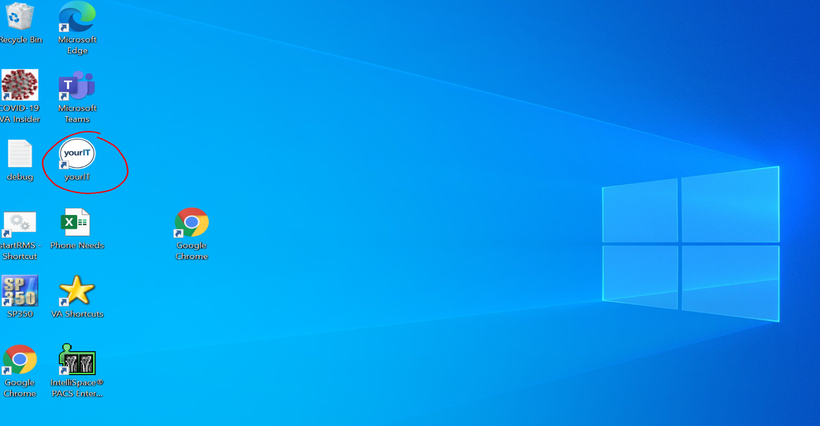
…Or you can go to “VA Bookmarks” on your internet tool bar, select “national” and scroll down to “yourIT”.
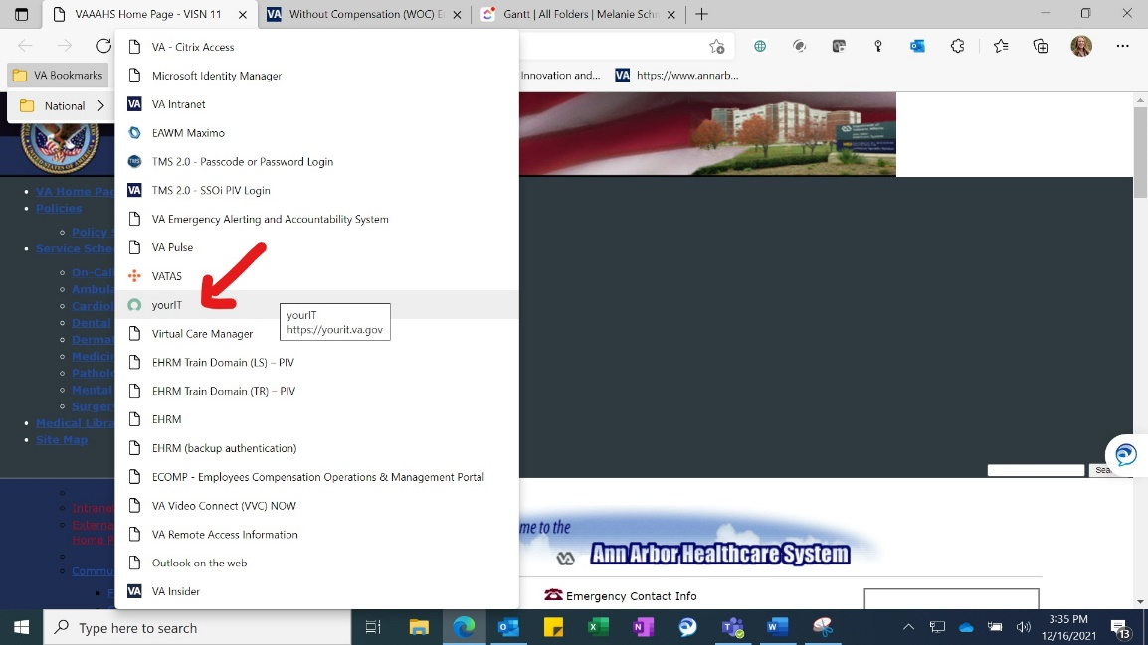
- Once in YourIT, you will see two options “Submit a Request” or “Report an Issue”. For new equipment or software, you will want to select “Submit a Request”. If you are having any issues with existing hardware or software, you will want to select “Report an Issue”.
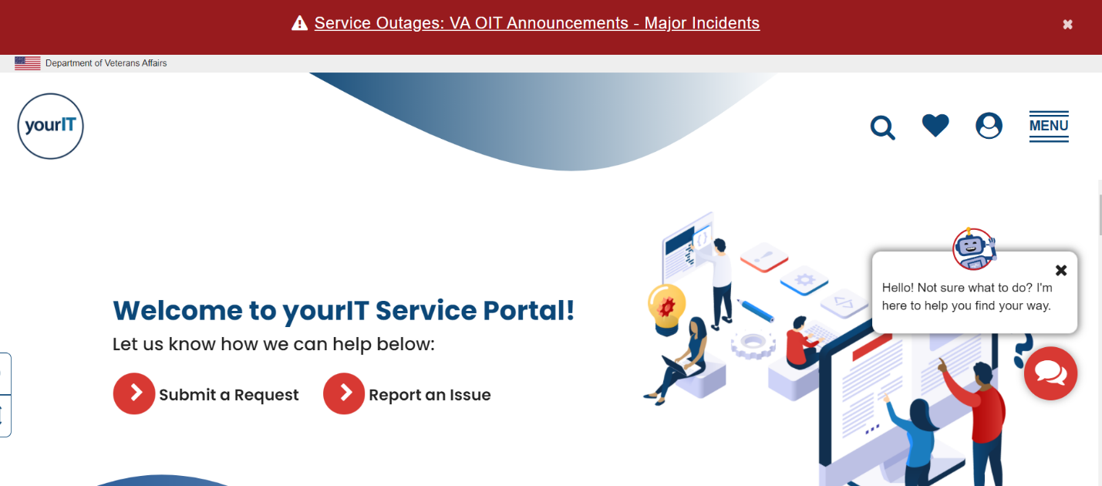

- Once you have made your selection, scroll down until you find the category that most closely represents your need. Please note there are categories specifically for new hires, so please read through the options carefully.

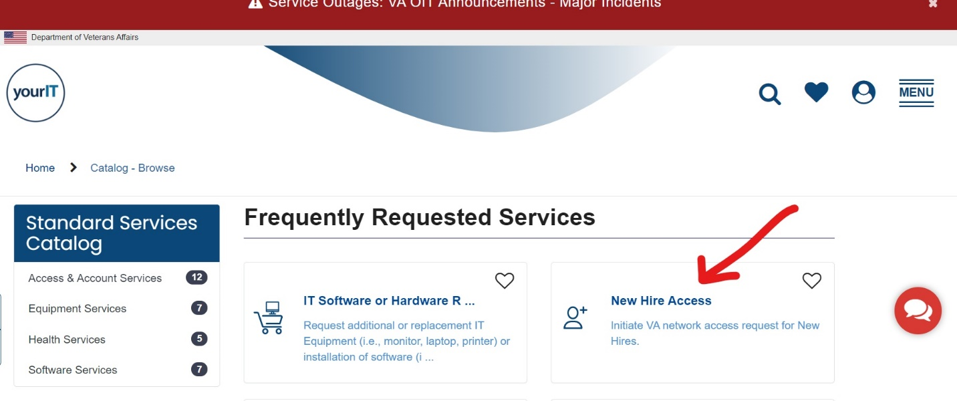

- Once you have selected the category that best suits your needs, you will be taken to an online form (see below). All areas where there is a red star MUST be filled out! Please also provide detailed justification for any equipment or software you are requesting. “I need it for my job” is NOT an adequate response and may result in your request being denied.
***Please note that anyone using VAIRRS/IRBNet will most likely need Adobe Acrobat DC to merge and edit documents. This feature DOES NOT COME STANDARD ON GOVERNMENT ISSUED COMPUTERS. Please submit your request for this software by following the instructions above.

