VATAS (TIMECARDS)
VATAS is your VA Time and Attendance System
Intermittent employees are required to email signed off hours worked and/or planned hours for the remaining week by 8 a.m. on the second Thursday.
Full-time/Part-time employees require permanent TOD (Tour of Duty). New employees will need to discuss their tour of duty with their supervisor and then email Zhoie Bigham (Zhoie.Bigham@va.gov) so she can enter it into the system. Full/Part time staff are required to submit leave requests. All leave requests will need to be submitted day of and/or in advance.
Click here to access VATAS (note that this link is only accessible on VA networks):
VA Identity and Access Management System (IAM)

How to enter leave request:
After entering your credentials, you will see the following menu
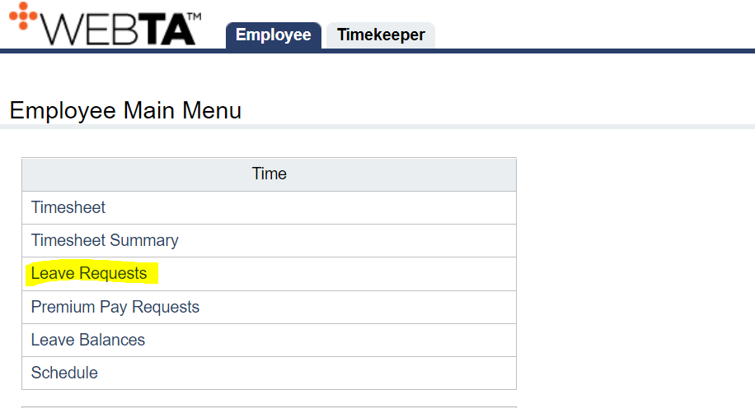
Leave Requests < Add Leave Request
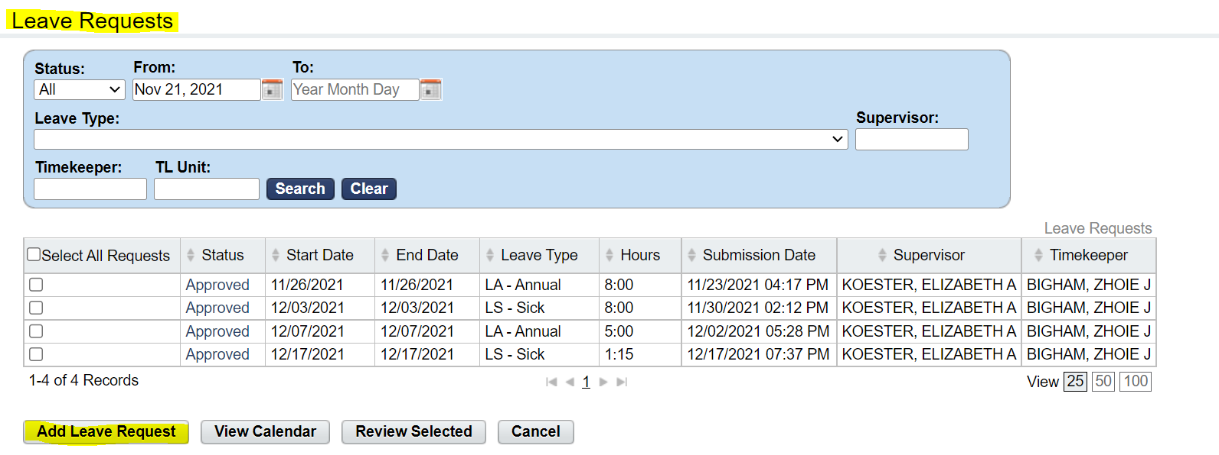
Add Leave Request < Leave Request Form
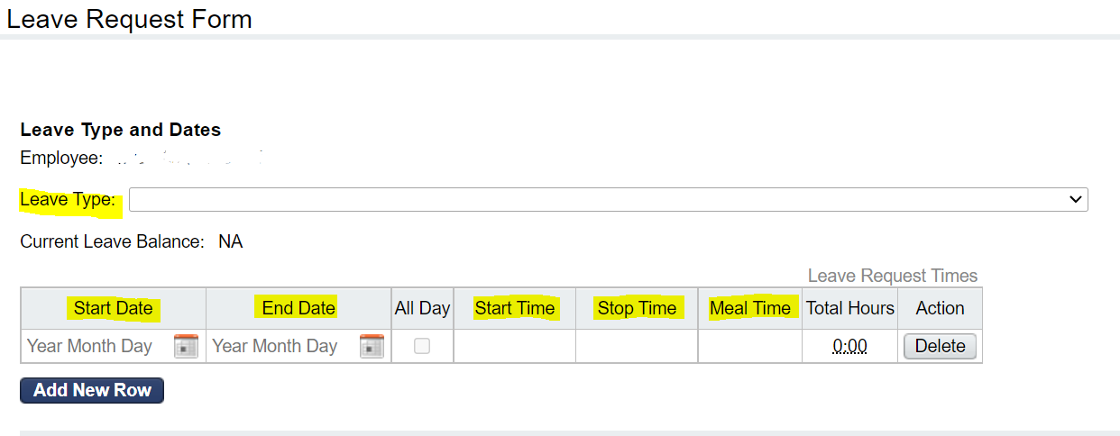
When entering your leave, you will need to make sure all highlighted areas are correct to avoid constant corrections and/or denying of leave request.
Leave Type – Please ensure you are entering the appropriate leave code
LA – ANNUAL
LS – SICK
CT – Comp Time Taken
Start/End Date – Start and End Date will ALWAYS be the same date (ex: Start: 12/31/21 End: 12/31/21)
Start/Stop Time – If taking time off for the day you will need to enter your TOD (Tour of Duty)
Mealtime – Full-time employees will need to incorporate 0:30 for mealtime when taking a full day off
Once you have entered the appropriate leave code it will display your current leave balance. You can also view your leave balance by going to the Employee Main Menu and clicking on Leave Balance.
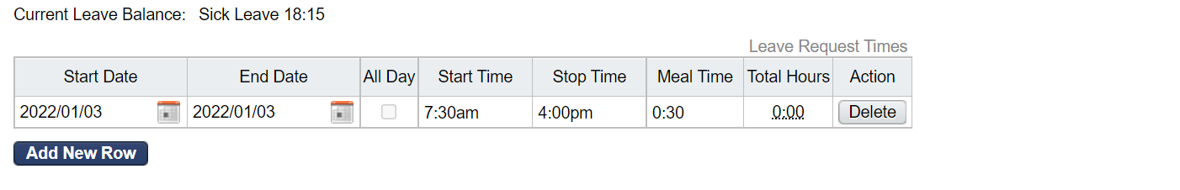
Ensure your Start and End Dates match and the appropriate Start and Stop Time are entered.
Continue to scroll down as there are additional questions that you need to answer before submitting.
Entering multiple Leave Request
When entering multiple leave requests, click on Add New Row and repeat above instructions. Please note you are only able to enter leave requests for one pay period at a time. You may only add a new row if it is in the same pay period. If your second request is in a different pay period, go back to the home screen and enter a new Leave Request.
Editing and Adding Leave
Please see the screenshot below for VATAS schedule for adding or editing leave requests.
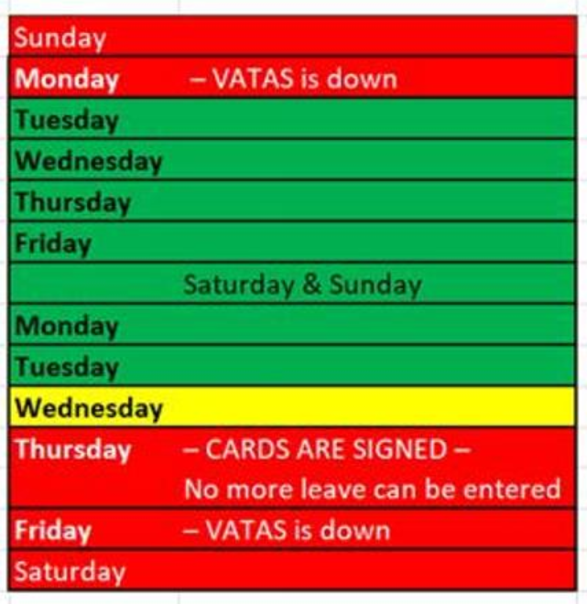 | Green days -VATAS is open  Yellow day - Use caution. Please no leave after COB.  Red days - VATAS is down. Please do not use the system as it could decertify your timecard and affect your paycheck.

Holiday Pay
Full-time employees will receive full pay for Federal Holidays, if full-time staff plan to work the holiday this request will need to be approved by your supervisor prior.
Part-time staff will only receive holiday pay if the holiday falls on day that you are scheduled to work. Unfortunately, Part-time employees do not qualify for “in lieu of” holidays.

FMLA/Parental Leave
Please contact Lizzy Koester (Elizabeth.Koester@va.gov) for questions on FMLA or parental leave.

